Structured Workplace Learning Record Book
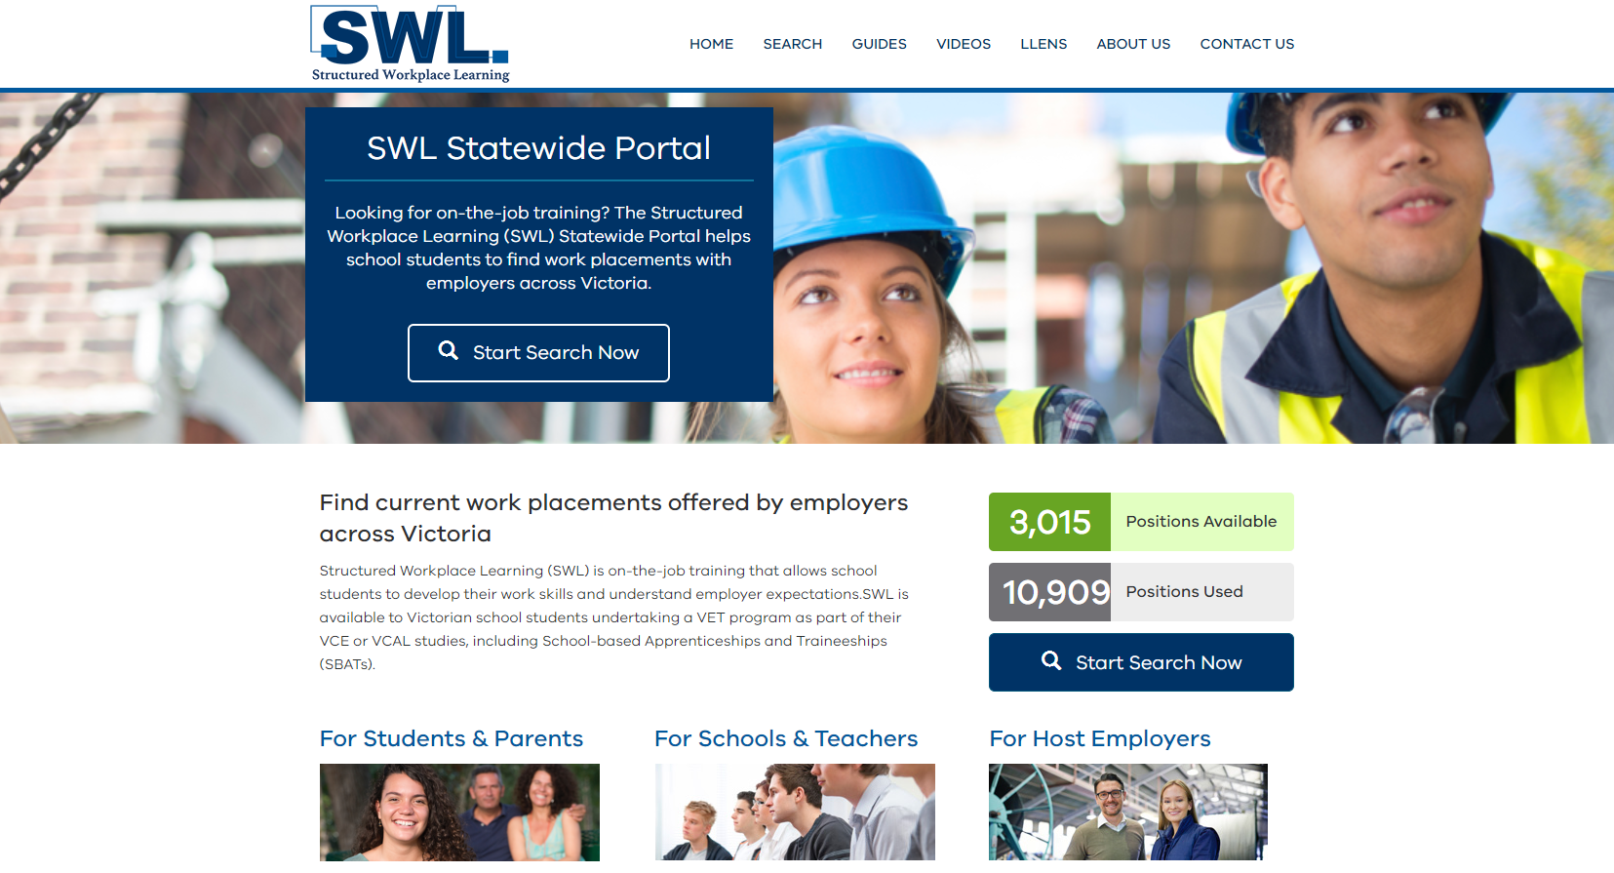
2020

Employability skills

Communication
You have to be a good talker and maybe also a good writer (depending on the job). You have to be confident in speaking to people face-to-face or over the phone and you might also need to write well enough to be understood in emails and memos.
Teamwork
You have to be good at working with people; this means both your workmates and other people that come into contact with your organisation. This will also include people from different genders, age groups and cultural backgrounds.
Problem solving
You have to find solutions when faced with difficulties or set-backs; you need to have a logical process for figuring things out even if you can’t think of a solution straight away.

Self-management
You need to be able to get on with your work without someone having to check up on you every five minutes. You should also be able to stay on top of your own deadlines and be able to delegate tasks to make sure things get done on time.
Learning
You should want to learn new things and be able to pick them up quickly. There are going to be many opportunities for you to try new things and acquire new skills in the workplace.
Initiative & enterprise
You need to think about the bigger picture and the future of the organisation you’re working for. Employers will value your ability to think creatively and make improvements to the way things are.
Planning & organising
You need to be able to organise yourself, plan project timelines and meet deadlines.

Technology
You'll need to know how to use a computer and how to touch-type for most office jobs but there are other types of technology that you might need to be familiar with depending on the industry you work in. Most jobs these days require you to use some form of technology.
Identification

Student name:
Telephone:
Mobile number:

Home School:

Address:
Telephone:

Emergency contact name & relationship to student:
Telephone home/work:
Mobile number:

Name of Business:
Supervisor Name:
Business Address:
Telephone:
Dates of work placement | From: | To:
Industry induction/orientation

It is expected that each student will be given some form of induction or orientation to the workplace upon arrival or prior to attending work placement. Businesses often have their own new staff induction and students should be inducted as though they are new staff members. The minimum points listed below should be included:

Describe the services the business provides
Introduce appropriate staff members and explain the management structure and reporting guidelines (if appropriate)
Outline key policies and procedures in your workplace
Explain OH & S in your workplace
Emphasise the importance of confidentiality
Show the student how to find their way around the workplace, pointing out key areas eg. toilets, break room, exits etc
Remind the student of any special requirements like dress standards (including safety equipment/clothing) or codes of conduct
Remind the student of the start, finish and break times
Run through Emergency and fire drill procedures
Explain to the student the progress of tasks throughout the week and show them a learning plan (if prepared)
Explain the procedure to follow and who to notify in the event of non-attendance as well as who to talk to regarding any problems
Sign induction/orientation form
View and note emergency contact information
View confidentiality form (if required)
View work placement diary

This induction/orientation will help to ensure the safety of the student, as well as assist them in making a quick and efficient transition into the workplace environment.

Industry induction/orientation completed

Supervisor signature: ______________________________________________________________ Date: _______________________

Student signature: ________________________________________________________________ Date: _______________________

Student attendance record

DATE | TIME COMMENCED | TIME FINISHED | HOURS | SUPERVISOR’S SIGNATURE
 |  | TOTAL HOURS

If the student is unable to attend on a day, please note the absence and the reason if known.

Day | Student’s diary of work undertaken during SWL | Date
Day 1 | ► ►
 | ► ►
 | ► ►
 | ► ►
Day 2 | ► ►
 | ► ►
 | ► ►
 | ► ►
Day 3 | ► ►
 | ► ►
 | ► ►
 | ► ►
Day 4 | ► ►
 | ► ►
 | ► ►
 | ► ►
Day 5 | ► ►
 | ► ►
 | ► ►
 | ► ►

Supervisor signature: ______________________________________________________________ Date: _______________________________________________

Supervisor’s assessment report
Please comment on the skills the student has acquired or demonstrated while at the workplace by writing the appropriate level Number below

Level 5 | Level 4 | Level 3 | Level 2 | Level 1 | N/A
Excellent | Very good | Good | Satisfactory | Unsatisfactory | Not Applicable

General | Level Rating
Attitude to the job
Persistence to tasks given
Appearance and dress for job requirements
Ability to deal with non routine/demanding situations
Ability to meet minimum quality requirements
Conduct
Application to task
Adjustment to the work environment
OH & S
Meets and observes OH & S Standards
Team member
Works as an effective member and contributes to the team
Self management
Ability to organise, manage time and meet deadlines.
Punctuality
Ability to work effectively
Working with others
Willingness to seek additional work
Ability to work with others and in a team
Communication
Ability to communicate effectively in the workplace and understand instructions
Initiative
Ability to work independently and complete set tasks
Using technology
Ability to use work-related equipment and technology

Supervisor’s comments

Please comment on the skills the student has acquired or demonstrated while at the workplace
Jobs skills: (Related to the job(s) the student was actually doing)

Organisational skills: (How the student organises, manages time and meets deadlines?)

Interpersonal skills: (How does the student communicate, interact with and behave towards others?)

Personal qualities: (Comment on the student's work attitude, punctuality, initiative etc)

General comments:

Supervisor signature: ______________________________________________________________ Date: _______________________________________________

Notes

SWL suggested task list

Students – please attach the suggested task list for your VET program here:

SWL Frequently asked questions….

What if I’m running late for work?
You should really try and avoid being late for work but if it does happen, you should call your supervisor or employer ASAP to make them aware you are on your way. It happens to everyone at some point so you shouldn’t feel too bad but don’t let it happen often.

What if I’m sick and can’t go to work?
If you are sick and can’t attend work then you must call both your work supervisor and your school. You need to ask your employer if they require a doctor’s certificate and if so, make an appointment to see one. Try and give your employer an idea of when you should be able to return to work.

What if I’m injured on the job?
You need to report any injury to your employer ASAP. There is nothing to be embarrassed about. If it is bad, they will contact your school and parent/guardian to let them know. You are covered by WorkCover as long as your SWL Arrangement Form is all signed.

What if I have a part-time job or sports on?
If you haven’t already let your career teacher, VET Coordinator and the employer know then you will need to chat it over with them. If you can make your SWL the priority, that would be best but some employers are happy to work around it.

Other things to consider…

Possible employment
If you enjoy your SWL and would like to work for your employer one day, don’t forget to ask how to be updated on future work opportunities before you leave. You could follow their social media and leave a positive comment as well.







